**.Aim:** Develop programs to understand the control structures of python.

**IDE:**

**What is a control structure in Python?**

A control structure in Python is a block of code that determines the flow of execution of a program. Control structures enable programmers to create programs that can make decisions based on certain conditions, repeat code blocks multiple times, or execute different code paths based on the values of variables.

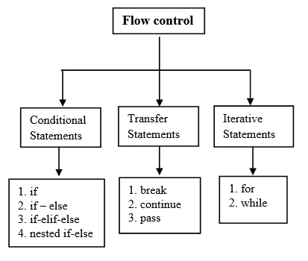

There are several types of control structures in Python:

1. Conditional statements: These structures allow the program to execute different code blocks based on the value of a condition. The if statement is the most common conditional statement in Python, and it can be accompanied by elif and else statements.
2. Loops: These structures allow the program to execute a code block repeatedly based on a condition. Python has two main types of loops: while loops and for loops.
3. Exception handling: These structures allow the program to handle errors and exceptions in a controlled manner, preventing the program from crashing. Python has a try-except structure for handling exceptions.
4. Function and method definitions: These structures allow the programmer to define reusable blocks of code that can be called from other parts of the program. Functions and methods can take arguments and return values, and they can also contain other control structures.

By using control structures in Python, programmers can create more complex and powerful programs that can make decisions, repeat actions, and handle errors in a controlled way.

1. Conditional Statements (if, else, elif)

Conditional statements are fundamental to programming and allow us to make decisions based on specific conditions. In Python, we use the keywords if, else, and elif to implement conditional branching. The syntax is clean and straightforward, making Python code highly readable.

1. if Statement

The if statement is used to execute a block of code if a given condition is True. If the condition is False, the code inside the if block is skipped.

Example:

x = 10

if x>5:

print(“x is greter than 5”)

Output

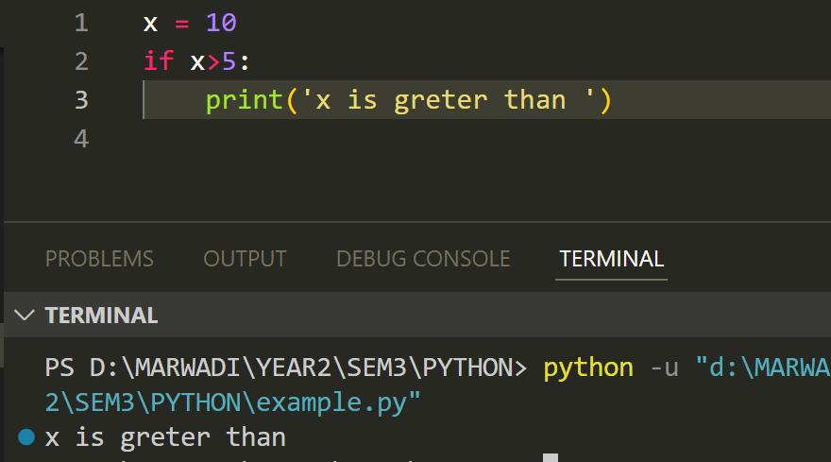

2. elif Statement

The elif statement is used when you have multiple conditions to check. It comes after an if statement and before an optional else statement. If the initial if condition is False, Python evaluates the elif condition. You can have multiple elif conditions.

Example:

x = 10

if x>5

print(“x is greater than 5”)

elif x ==5:

print(“x is equal to 5”)

else:

print(“x is less than 5”)

Output

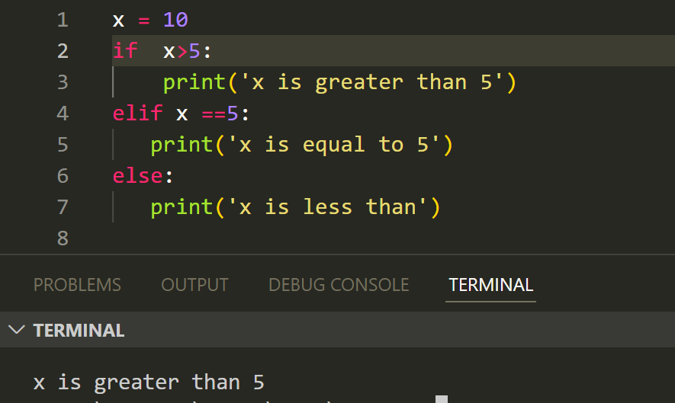

3. else Statement

The else statement is used to execute a block of code when the conditions specified in the if and elif statements are not met.

Example

if x>5:

print(“x is greater than 5”)

else:

print(“x is not greater than 5”)

Output

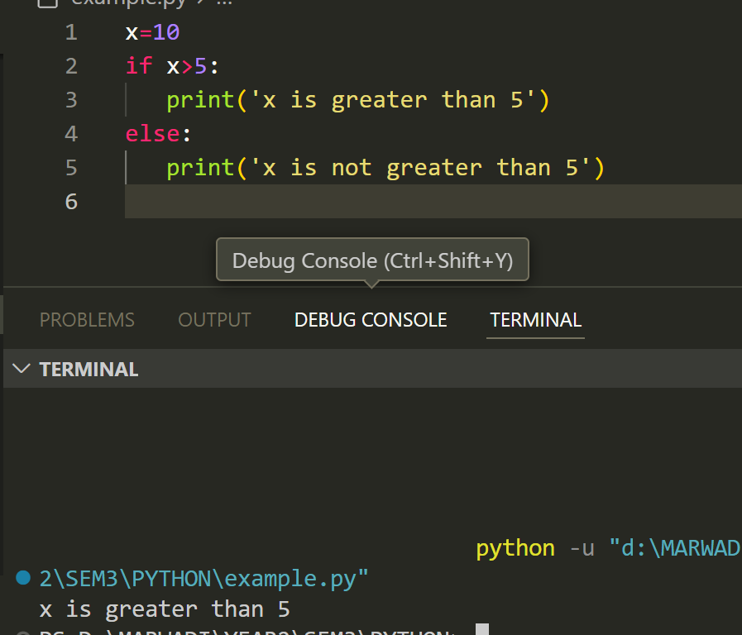

Nested if-else statements

Nested if-else statements in Python allow you to test multiple conditions and execute different code blocks based on the results of these tests.

Example

age = 35

if age >= 60:

print("You are a senior citizen.")

else:

if age >= 18:

print("You are an adult.")

else:

print("You are a teenager.")

Output

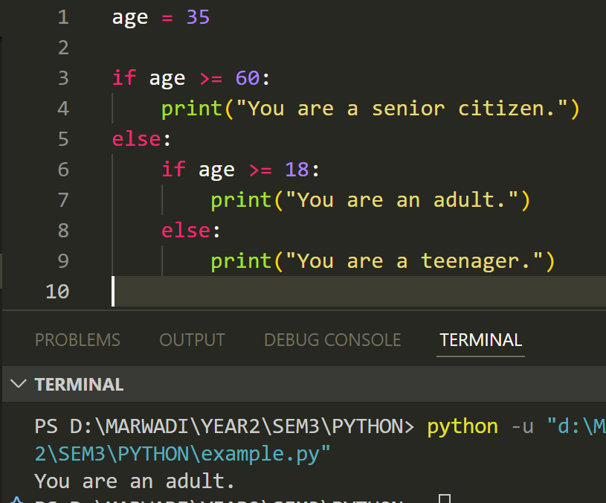

Example

num = 10

if num > 0:

if num % 2 == 0:

print("The number is positive and even.")

else:

print("The number is positive but odd.")

else:

print("The number is not positive.")

Output

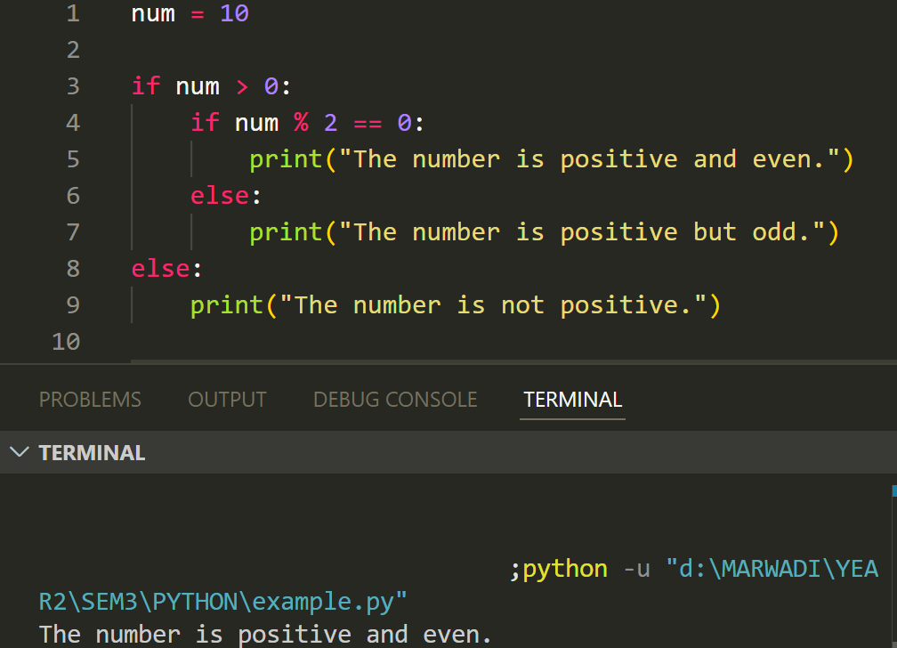

Looping Statements

1. for Loop

The for loop is used to iterate over sequences like lists, tuples, strings, and dictionaries. It allows you to perform an action for each item in the sequence.

Example

Fruits = ["apple", "banana", "cherry"]

for fruit in fruits:

print(fruit)

Output

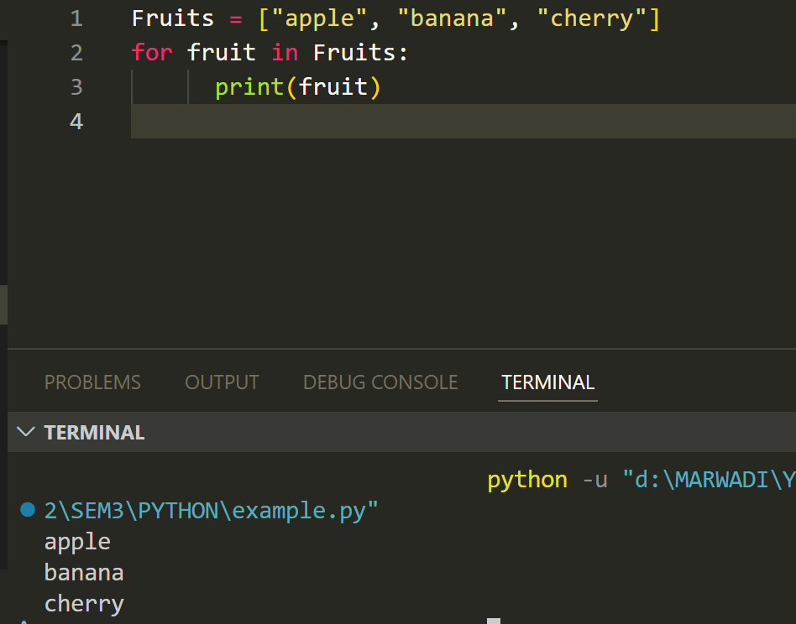

2. while Loop

The while loop is used to repeatedly execute a block of code as long as a specified condition is True.

Example

x = 1

while x<=5:

print(x)

x+=1

Loop Control Statements

Python provides several loop control statements to enhance the functionality of loops.

break: The break statement is used inside a loop (while loop or for loop). When the condition specified in the if statement is true, the break statement is executed, and the control is transferred to the next statement after the loop. This means that the loop is terminated, and the code execution continues from the statement after the loop.

Example

for x in range(1,6):

if x==3:

break

print(x)

Output

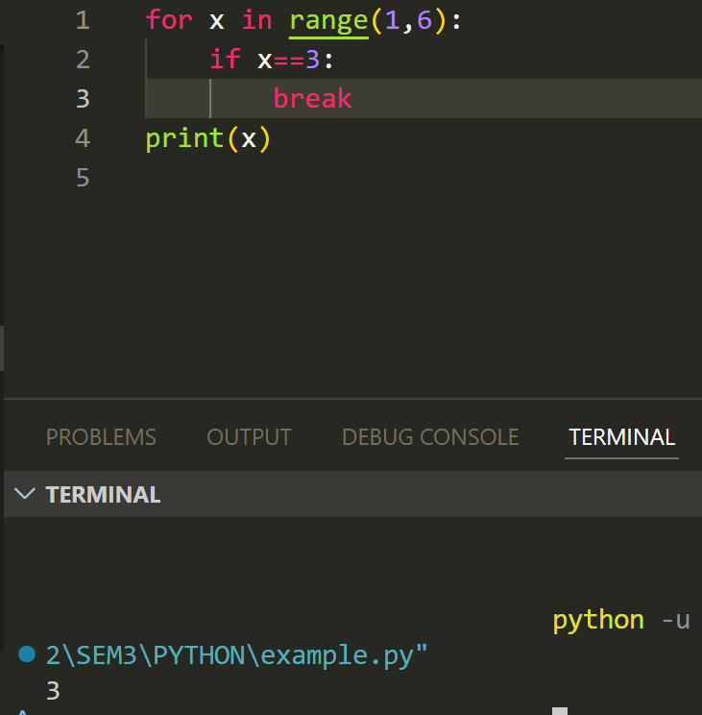

continue: The continue statement is used to skip a particular iteration of a loop when a specific condition is met. When a continue statement is executed inside a loop, it skips the current iteration of the loop and jumps to the next iteration.

Example

for x in range(1,6):

if x==3:

continue

print(x)

Output

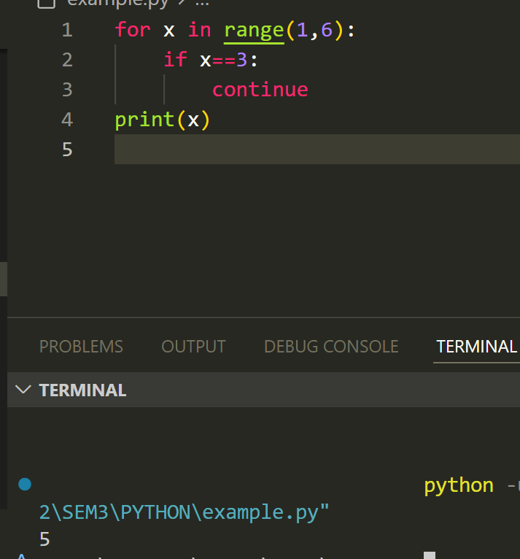

pass: The pass statement is a placeholder in Python. It doesn't do anything but is used when a statement is syntactically required. It is often used as a placeholder for functions, loops, or conditional blocks that will be implemented later.

Example

for x in range(1,6):

if x == 3:

pass

print(x)

Output

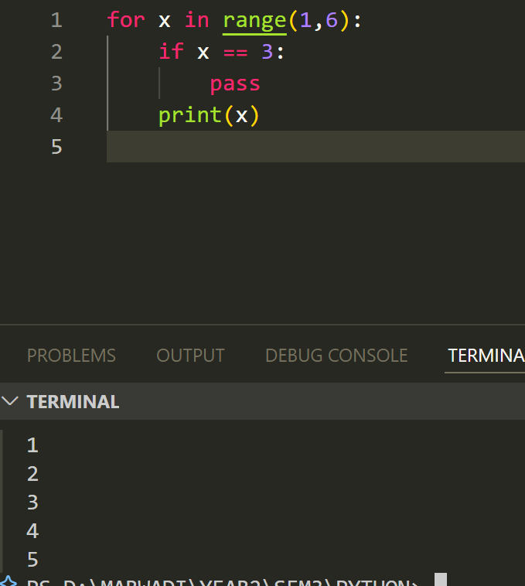

**Try and Except Statement – Catching Exceptions**

* In Python, you may catch and deal with exceptions by using the try and except commands.
* The try and except clauses are used to contain statements that can raise exceptions and statements that handle such exceptions.

Example

**try**:

number = int(input("Enter a number: "))

result = 10 / number

print("The result is:", result)

**except** ZeroDivisionError:

print("Division by zero is not allowed.")

**except** ValueError:

print("Invalid input. Please enter a valid number.")

Python Function:

Python functions are reusable code blocks that carry out particular tasks, helping programmers structure their code and make it easier to read. By preventing duplication, functions make the code more modular and manageable. The 'def' keyword, the function name, and any parameters included in parenthesis define a function. The code to be performed is contained in the function body, and the 'return' statement allows the function to produce a result.

Types of Functions in Python

Python supports various types of functions, each serving different purposes in programming. Here are the main types of functions in Python, along with examples:

1. Built-in Functions

These functions are pre-defined in Python and can be used directly without any further declaration.

Example

my_list = [1, 2, 3, 4, 5]

print(len(my_list))

output:

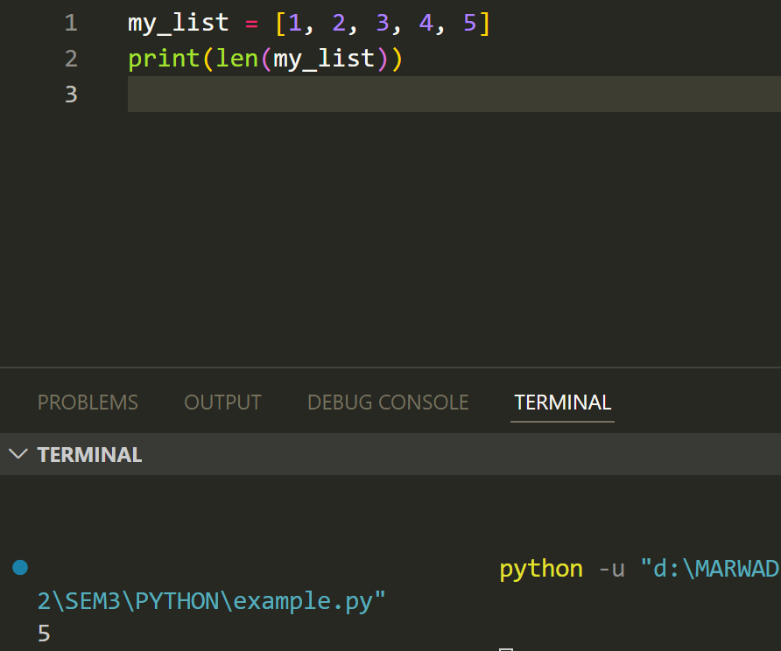

2. User-defined Functions

These are functions that users create to perform specific tasks.

Example

def add_numbers(a, b):

    return a + b

result = add_numbers(3, 5)

print(result)

output:

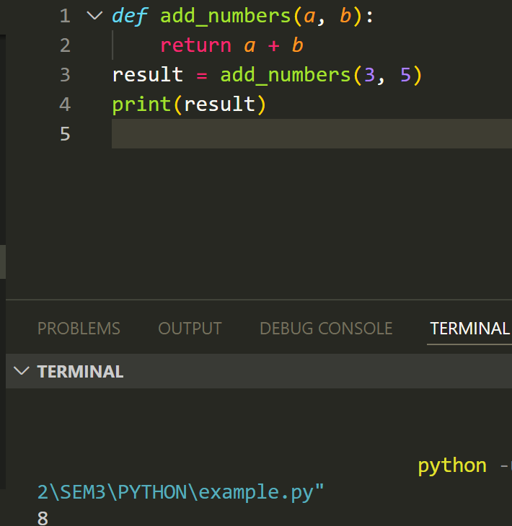

3. Anonymous Functions (Lambda Functions)

These are small, unnamed functions defined using the lambda keyword. They are typically used for short, simple operations.

Example

add = lambda x, y: x + y

print(add(3, 5))

Output

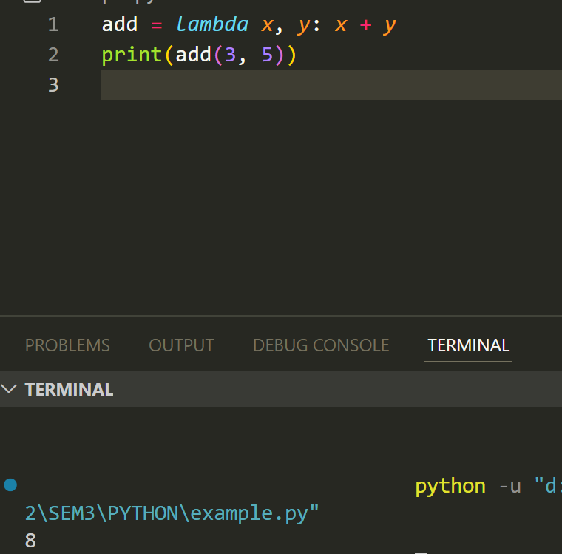

4. Recursive Functions

These are functions that call themselves within their definition. They help solve problems that can be broken down into smaller, similar problems.

Example

def factorial(n):

if n == 1:

return 1

else:

return n * factorial(n - 1)

print(factorial(5))

Output

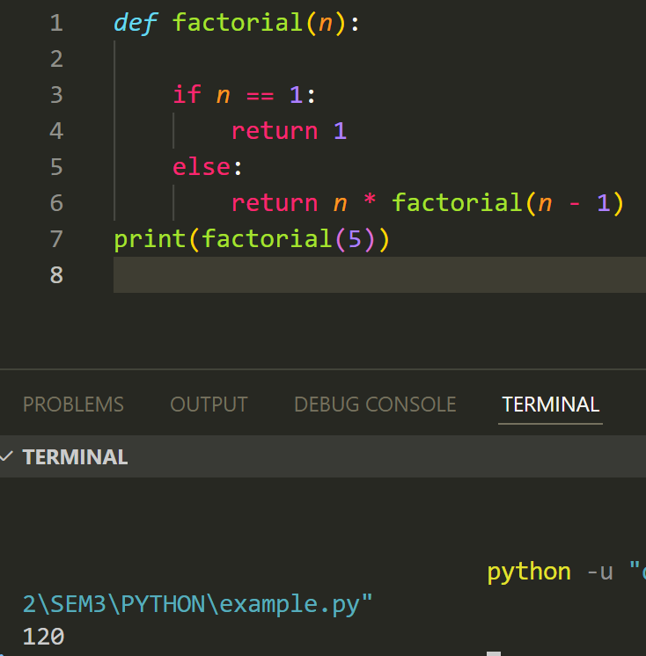

5. Higher-Order Functions

These functions can take other functions as arguments or return them as results. Examples include map(), filter(), and reduce().

Example

def square(x):

    return x * x

numbers = [1, 2, 3, 4, 5]

squared_numbers = list(map(square, numbers))

print(squared_numbers)

output:

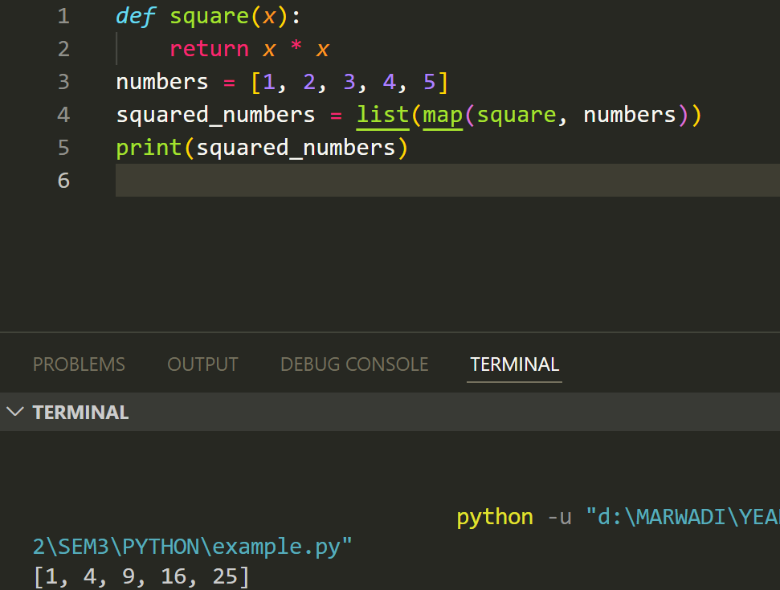

6. Generator Functions

These functions yield values one at a time and can produce a sequence of values over time, using the yield keyword.

Example

def generate_numbers():

    for i in range(1, 6):

        yield i

for number in generate_numbers():

    print(number)

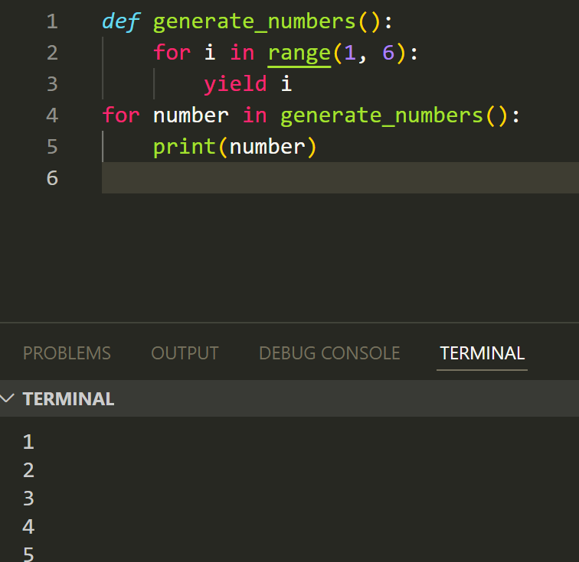

**Post Lab Exercise:**

1. Write a Python program to print all odd numbers between 1 to 100 using a while loop.

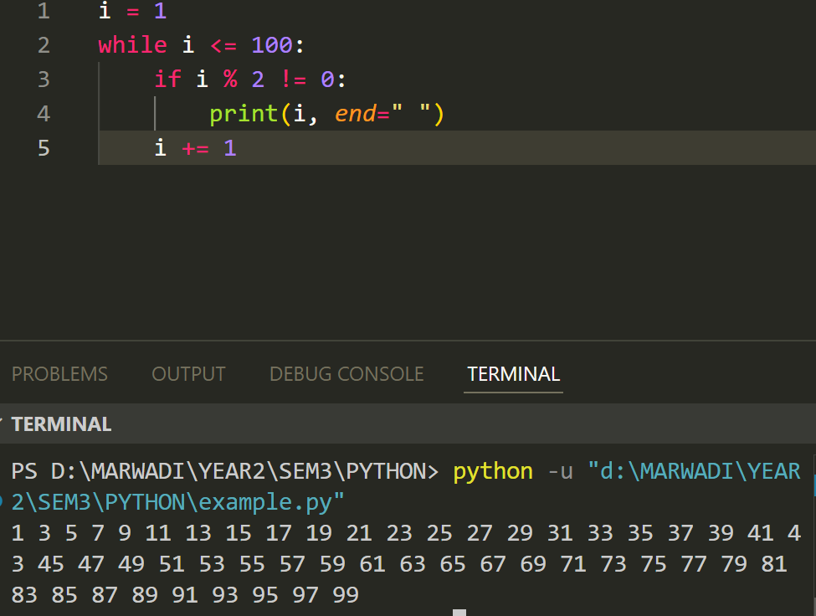

1. Write a Python program to find the sum of all natural numbers between 1 to n.

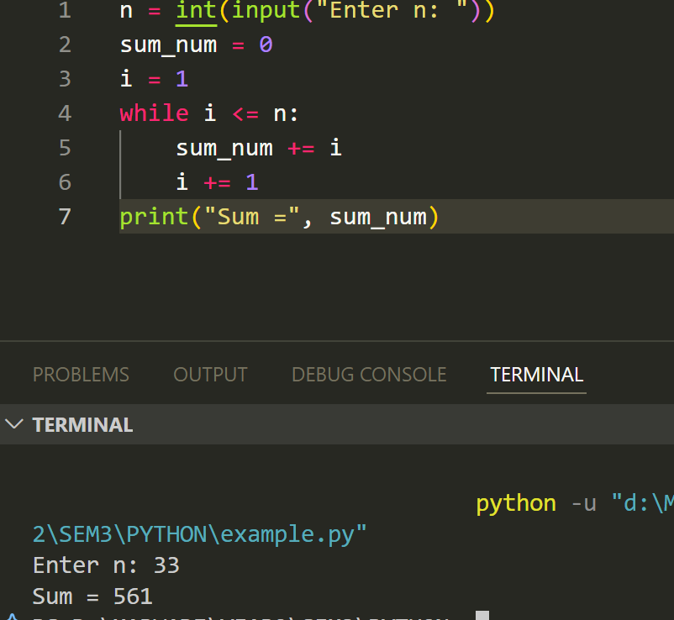

1. Write a Python function program to count a number of digits in a number.

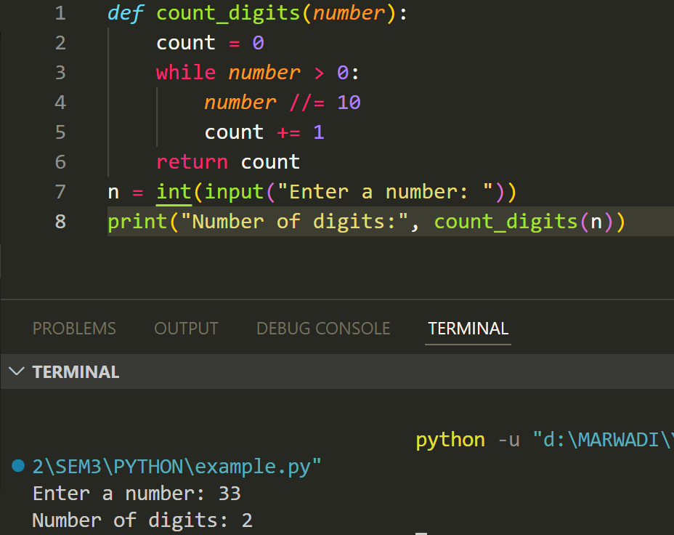

1. Write a Python program to find the first and last digits of a number.

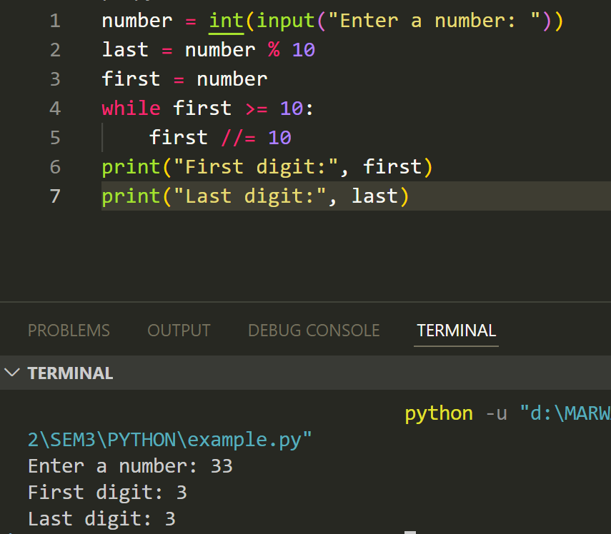

1. Write a Python program to swap the first and last digits of a number.

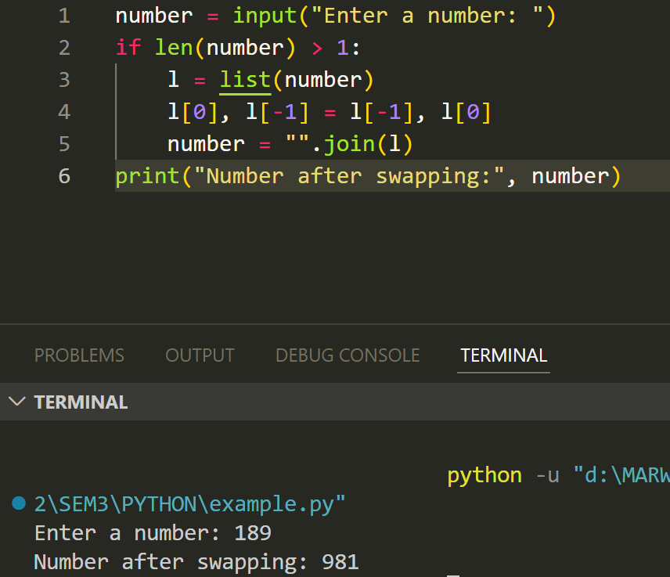

1. Write a Python program to calculate the product of digits of a number.

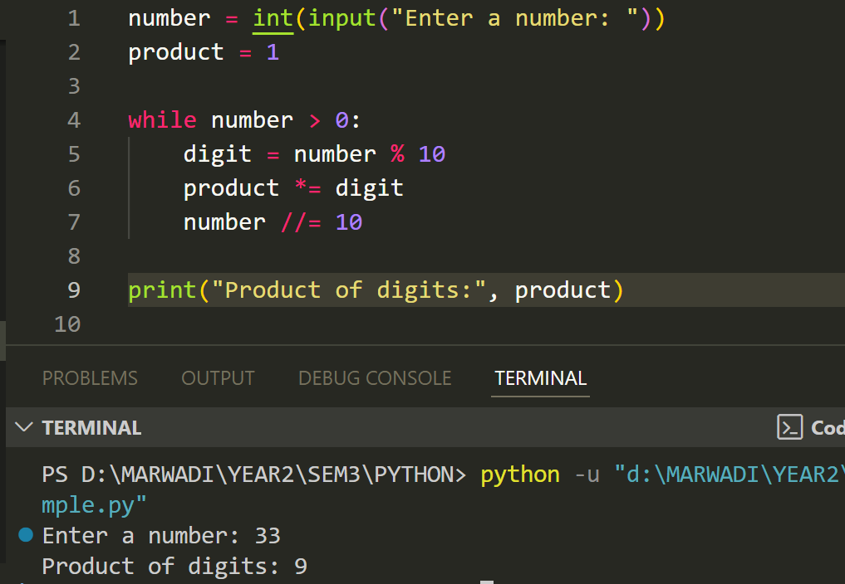

1. Write a Python program to enter a number and print its reverse

